School Council Meeting
Friday 16th November 2018

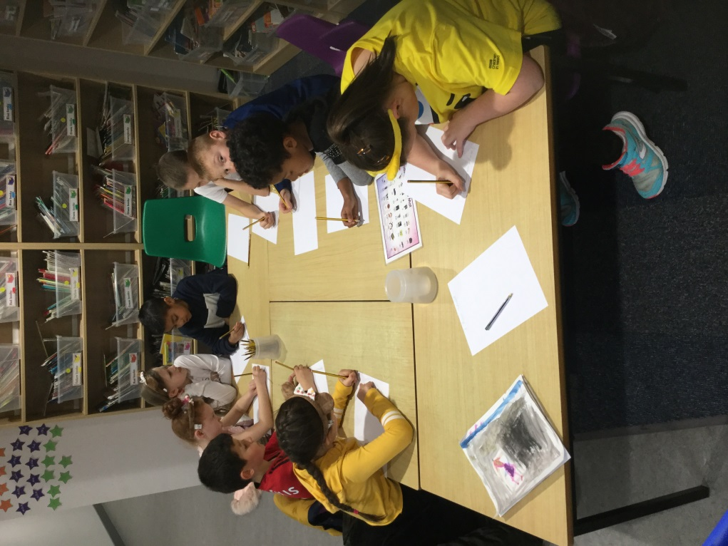
At today’s meeting the School Council wrote their mission statement and a short list of their aims.
Mission Statement
Working together to ensure Acre Hall Primary School is a happy and successful place to learn and achieve.
Aims
- To make sure all children in school understand the role of the School Council.
- To listen to and act upon the children’s ideas from each class.
- To support different charities and raise money for school funds.

