INFORMATION PACK
Teacher early years with TLR
Bright Futures Educational Trust
Bright Futures Educational Trust (The Trust) is a multi-academy trust set up in 2011. The Trust is made up of a richly diverse group of schools in Greater Manchester and Blackpool. We are passionate about working together within and beyond the Trust to achieve our aspirational vision: the best for everyone, the best from everyone. We are an organisation that is underpinned by values of: community, integrity and passion. In everything we do, we remember that we are accountable to the children, families and communities that we serve.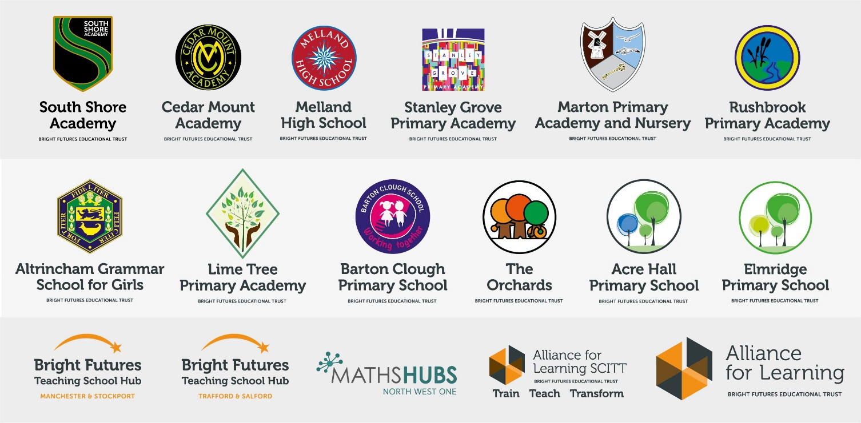
Our schools have their own identities and form one organisation and one employer, Bright Futures Educational Trust. Bright Futures’ Board of Trustees maintains strategic oversight of the Trust and delegates some of its responsibilities to the Executive Team, Principals and local governing bodies. We place a high value on integrity and probity and take seriously our accountabilities for making the best use of public money. How decisions are made is described in our delegation framework. You can find out more about the Trustees and the Executive Team on our website: http://bfet.co.uk/about-us/.

The central team, comprises the Executive Team: John Stephens, CEO; Edward Vitalis, Chief Operating Officer; Gary Handforth, Director of Education; Lisa Fathers, Director of Teaching School and Partnerships and Lynette Beckett, Director of HR & Strategy. The focus of these roles is to work with schools, providing high quality and timely guidance, leadership, challenge and support. In addition to the executive team, we have central operations for finance, HR, educational psychology and Digital Technologies. Please see our website brochure which explains our central operations: Working together for a Bright Future.
Bright Futures Development Network is another important outward facing component of our organisation. Underneath this umbrella we have 5 network hubs. ‘The Alliance for Learning’ (AFL) which provides school improvement services and CPD to over 700 schools (http://allianceforlearning.co.uk/); a North West Maths’ hub providing mathematics training and coaching to 500 schools: a SCITT (School Centered Initial Teacher Training) which is the largest in the North West. After significant national reforms to the teaching school policy, Bright Futures was designated with two new large-scale Teaching School Hubs in 2021. The areas we serve are Manchester, Stockport, Salford and Trafford.

Collaboration and strong relationships form one of the ‘commitments’ in our Strategy and all components of the Bright Futures’ family work closely together. Our Strategy was developed collaboratively and can be found on our website: Our Strategy.

The Orchards School

The Orchards School opened in September 2016, providing high quality places for primary-aged children with moderate to complex special educational needs.

The Orchard’s is a specialist free school currently has places for up to 96 children from the ages of 3 – 11. The Orchards School caters for children with a wide range of special educational needs and disabilities. All of the children at the school have difficulties with cognition and learning, with the majority having moderate to severe learning difficulties. Some of our children have profound and multiple difficulties, some have social communication difficulties including Autism and some have sensory impairments. The Orchards does not cater for children where Social, Emotional and Mental Health needs are identified as a primary need.

At The Orchards we celebrate every child and see each pupil as an individual. We want all our children to flourish and achieve their very best in a safe and stimulating learning environment. We encourage all our children to be reflective, creative and independent global citizens who are effective communicators and respectful of themselves and of others. We believe that by working collaboratively and that by building strong relationships with all stakeholders then we can provide the best opportunities to our learners and enable them to achieve their unique potential. We truly embrace our core purpose to ‘Champion Remarkable Children’.

In September 2020 the school moved into its permanent home. Since then it has seen sustained and rapid growth of pupil numbers. This is an exciting opportunity to become a part of a positive and our innovative team that aims to provide high quality support for the children and their families.

Currently judged as “good” by Ofsted, we are ambitious and are well placed to becoming outstanding. We are committed to providing our pupils with the best possible learning opportunities and supporting them in their development.

We are proud to be a part of Bright Futures Education Trust which links us with other inspirational and innovative schools across Trafford and beyond. At The Orchards we are passionate about providing our children with meaningful learning experiences which promote their development through a holistic curriculum. We focus on ensuring high quality outcomes through responding individually to each child’s point of learning and ensuring that we meet that point of learning by using creative, innovative and aspirational teaching or support.

The Orchards has a highly skilled team of teachers and teaching assistants who ensure that every child’s needs are met. Our teachers lead their class teams through shared outcomes which are informed by parents, families, therapists and multi-agency support teams. We believe in the power of truly inclusive provision and place that at the heart of our school’s mission and vision.

Ensuring our staff have the knowledge and expertise to meet the needs of our learners is a priority for us and as such we have a comprehensive programme of induction for new staff and whole school training. We also provide individual training for individual staff and small groups of staff where appropriate. Our induction and training programme includes safeguarding, health and safety, and moving and handling. Our training programme ensures staff are kept up to date on curriculum matters linked to the School Development Plan and also on meeting the additional needs of learners e.g. training on alternative communication strategies such as sign along / use of symbols.

Why work for us?

We offer a great opportunity to join an organisation which really lives its values. Our working environment is very inclusive and whilst you can expect to be challenged in your role, you will be supported through professional learning, treated fairly and with dignity and respect.

Terms and Conditions
Salary: Main scale + SEN allowance (£2,270) + TLR 2a (£2873.00 possible for suitably experienced candidate). Pay progression is linked to performance. THIS JOB IS NOT SUITABLE FOR NQTs.
Working weeks/hours: Full time, permanent, Monday-Friday.
Pension: Teachers Pension Scheme: https://www.teacherspensions.co.uk/

Other: We offer salary sacrifice schemes for purchasing cycles and technology, through monthly interest free salary deductions.
How to Apply
We can only accept completed application forms, rather than CVs. This is because the regulatory guidelines of Keeping Children Safe in Education, require us to check various details of job applicants and an identical application format for each candidate enables us to do this.
Our new portal contains our application form and disclosure of criminal background form. The portal https address is https://bfet.jotform.com/211106271850950. Please upload the forms by 5pm on 19/05/2021. This is the first time that we have used this portal so please call the school office on 0161 748 0670 if you encounter any problems.

The selection process will in all likelihood be conducted virtually, so candidates will need access to a device with a camera and a microphone to participate. The selection will take place on 21/05/21.

Keeping Children Safe in Education
Bright Futures Educational Trust is committed to safeguarding and promoting the welfare of children and young people and we expect all staff and volunteers to share this commitment. This post is exempt from the Rehabilitation of Offenders Act 1974; pre-employment checks will be carried out and references will be sought for shortlisted candidates and successful candidates will be subject to an enhanced DBS check and other relevant checks with statutory bodies.
Data Privacy
You can the details of how we use the personal data that you provide us with in our Job Applicants’ privacy notice on our website: http://bfet.co.uk/wp-content/uploads/2018/07/BFET-Applicant-privacy-notice-002.pdf

JOB DESCRIPTION
Teacher early years
Reporting to Head of School (Helen O’Brien)

1. Knowledge and understanding of:
1.1 The school’s aims, priorities and action plans.
1.2 Any statutory curriculum requirements and the requirements for assessment, recording and reporting of pupils’ attainment and progress.
1.3 The characteristics of high quality teaching and the main strategies for improving and sustaining high standards of teaching, learning and achievement for all pupils.
1.4 The implications of the code of practice for special educational needs for teaching and learning.

2. Teaching
2.1 Planning and preparing courses and lessons.
2.2 Teaching pupils according to their educational needs including the setting and marking of their work.
2.3 Curriculum coverage, continuity and progression in the subject for all pupils, for those with special educational needs

3. Pastoral and communication
3.1 Promoting the general progress and well-being of individual pupils and of any class or group of pupils assigned.
3.2 Providing guidance and advice to pupils on educational and social matters and on their further education and future careers.
3.3 Making records of and reports on the personal and social needs of pupils.
3.4 Communicating and consulting with the parents of pupils

4 Assessment, reporting and monitoring
4.1 Provide oral and written assessments, reports and references relating to individual pupils and groups of pupils.
4.2 Establish clear targets for pupils’ achievement, and evaluate progress and achievement by all pupils, including those with special needs.
4.3 Use data effectively to identify pupils who are underachieving and, where necessary, create and implement effective plans of action to support those pupils.
4.4 Ensure that information about pupils’ achievements in previous classes and schools is used effectively to secure good progress.

5. Discipline, Health and Safety
5.1 Maintaining good order and discipline among the pupils and safeguarding their health and safety both on the school premises and when they are engaged in authorised school activities elsewhere.

6. Staff Meetings
6.1 Participate in and lead school meetings relating to the curriculum, pedagogy, administration and general organisation of the school.

7. Professional Development
7.1 Participate in further training and professional development activities as a teacher
7.2 Carry out regular review of teaching methodology and programmes of work.

8. Equal Opportunities
8.1 Promote equal opportunities within the school and to seek to ensure the implementation of the Authority's and the school's Equal Opportunities policy.

9. Other duties
Job descriptions are expected to give candidates clear guidance on what they are expected to achieve; however they rarely capture all tasks and responsibilities. All members of staff are expected occasionally to undertake other duties not detailed above, but within the scope of the job.

JOB DESCRIPTION
Early years TLR
Reporting to Head of School (Helen O’Brien)

JOB PURPOSE SUMMARY:
The TLR post holder will be a leading practitioner, modelling effective pedagogy and practice to inspire Early Years team members. They will be accountable for the management and delivery of high quality teaching and learning in the Early Years.

KEY RESPONSIBILITIES AND ACCOUNTABILITIES:
- To be a leading practitioner, modelling effective methodology and practice to inspire Early Years team members.
- To lead, manage and evaluate the delivery of high quality teaching and learning in Early Years. This to include high quality indoor and outdoor learning environments which promote learning through play.
- To be passionate and knowledgeable about early communication, including the use of alternative communication, and have an excellent knowledge of how this can be developed in play.
- To play a key role in leading school improvement.
- To ensure regular formative and summative observations are made of pupils, to monitor and maximise outcomes for children and ensure school has a thorough knowledge of developmental bands to support forward planning.
- To translate the vision into best practice through innovative planning and teaching that provides high quality learning.
- To have a thorough knowledge of Early Years practice guidance and implement this guidance day to day throughout the department.
- To be skilled in matching Early Years quality provision with outcomes in EHCPs.
- To provide high quality CPD to staff.
- To promote and safeguard the welfare of children, carrying out and acting upon risk assessments as necessary.

PERSON SPECIFICATION
CATEGORY | ESSENTIAL | DESIRABLE | EVIDENCE
Qualifications & Training | Graduate.  Qualified Teacher Status.  EYFS experience  3 years of teaching experience | Additional training in SLCN / ASC or disability | Letter of application.  Application Form.
Experience | An outstanding Early Years Practitioner | Experience of having taught children with complex needs in an early years setting | Letter of application.  Application Form.
Skills, knowledge and aptitude | Thorough understanding of the Early Years Curriculum and most recent changes.  Experience of managing transitions to & from EYFS.  Knowledge of how communication can be supported through play & interaction.  Thorough knowledge of pedagogy and developmental milestones.  Ability to identify ways of personalising and tailoring learning according to need. | Experience of alternative communication  Experience intensive interaction | Letter of application.  Interview.  Referees.
Communication | Ability to communicate effectively one to one or in a large or small group.  Ability to communicate clearly in writing/orally.  Ability to present to relevant audiences. | Experience of liaising effectively with outside agencies.  Experience of developing links.  Experience of encouraging parent/family liaison and participation | Application Form.  Interview.
Organisational skills | Ability to plan and organise effectively.  Ability to meet deadlines and to encourage others to do the same. | Ability to work under pressure.  Ability to be flexible and adaptable. | Application Form.  Interview.
Personal Attributes | Team player  Ability to lead others  Energy, Creativity and good sense of Humour  Flexibility |  | Letter of application.  Interview.  References.

